**ABC Call Volume Trend Analysis**

**Description**

A Customer Experience (CX) team plays a crucial role in a company as they analyze customer feedback and data, derive insights from it, and share these insights with the rest of the organization. This team is responsible for a wide range of tasks, including managing customer experience programs, handling internal communications, mapping customer journeys, and managing customer data, among others.

In the current era, several AI-powered tools are being used to enhance customer experience. These include Interactive Voice Response (IVR), Robotic Process Automation (RPA), Predictive Analytics, and Intelligent Routing.

One of the key roles in a CX team is that of the customer service representative, also known as a call center agent. These agents handle various types of support, including email, inbound, outbound, and social media support.

Inbound customer support, the focus of this project, involves handling incoming calls from existing or prospective customers. The goal is to attract, engage, and delight customers, turning them into loyal advocates for the business.

In this project, we will delve into the world of Customer Experience (CX) analytics, specifically focusing on the inbound calling team of a company. We are provided with a dataset that spans 23 days and includes various details such as the agent’s name and ID, the queue time (how long a customer had to wait before connecting with an agent), the time of the call, the duration of the call, and the call status (whether it was abandoned, answered, or transferred). We will use our analytical skills to understand the trends in the call volume of the CX team and derive valuable insights from it.

**Data Pre-Processing:**

**Handling Null Values:**

We found that all the rows where Agent_Name and Agent_ID were Null denote abandoned calls. Some calls where Wrapped_By was Null were answered or transferred calls. So we replaced them with the value ‘Agent.’ The rest of the Null values were replaced by the value ‘Not Available.’

**Data Analytics Tasks:**

Task A: Average Call Duration: Determine the average duration of all incoming calls received by agents. This should be calculated for each time bucket.

Your Task: What is the average duration of calls for each time bucket?

Result:

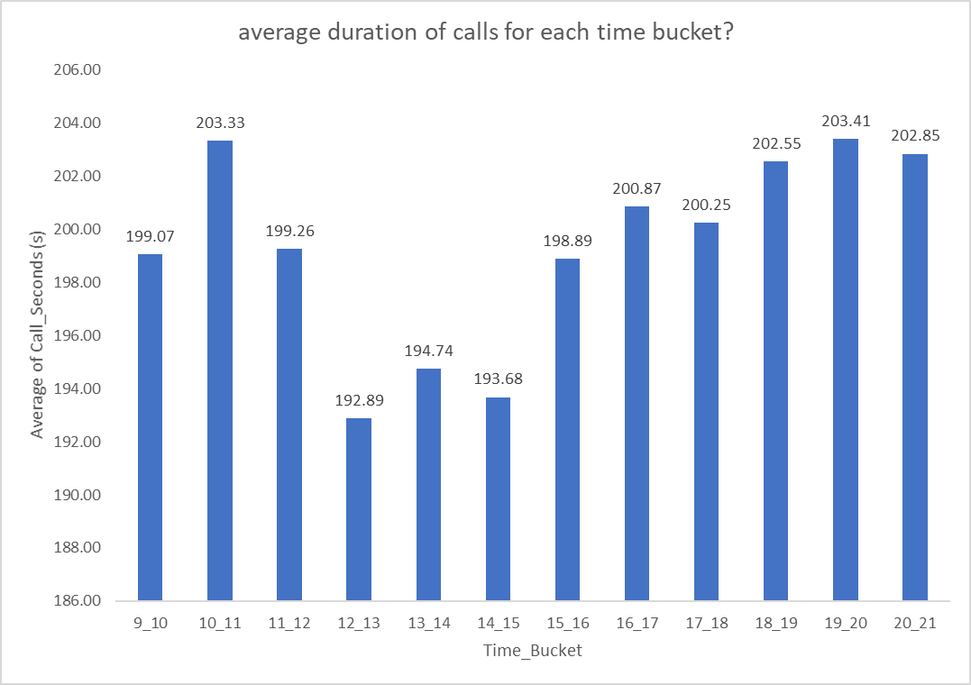

The overall Average Call Duration is 198.62seconds. We observe that the Average Call Duration first peaks in the morning hours before dropping to a below-average value during lunch hours and then increases again to an above-average value.

Task B: Call Volume Analysis: Visualize the total number of calls received. This should be represented as a graph or chart showing the number of calls against time. Time should be represented in buckets (e.g., 1-2, 2-3, etc.)

Your Task: Can you create a chart or graph that shows the number of calls received in each time bucket?

Result:

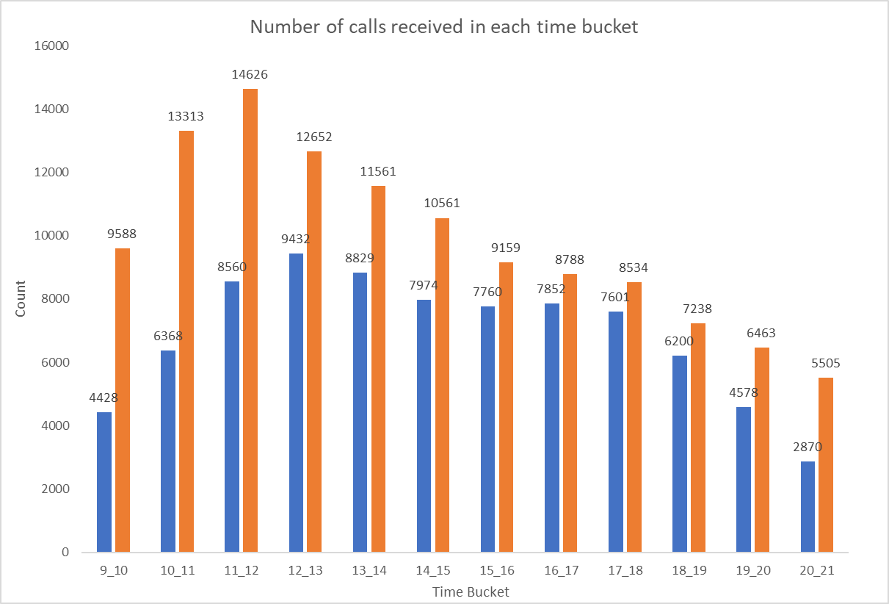

We observe that the number of received calls first increases with time before droppingdown. We can also observe that the number of abandoned calls is very high in the morning hours, and as the day progresses, the number of abandoned calls reduces.

Task C: Manpower Planning: The current rate of abandoned calls is approximately 30%. Propose a plan for manpower allocation during each time bucket (from 9 am to 9 pm) to reduce the abandon rate to 10%. In other words, you need to calculate the minimum number of agents required in each time bucket to ensure that at least 90 out of 100 calls are answered.

Your Task: What is the minimum number of agents required in each time bucket to reduce the abandon rate to 10%?

Result:



We can observe that to maintain a maximum of a 10% abandon rate, we need to increase the availability of agents in the morning hours by a large margin, as in these hours, the number of incoming calls is quite high, and the number of agents available currently is quite low. During afternoon hours and late evening hours, we need to increase the availability of agents by a slight margin to maintain a maximum of 10% abandon rate.

Task D: Night Shift Manpower Planning: Customers also call ABC Insurance Company at night but don't get an answer because there are no agents available. This creates a poor customer experience. Assume that for every 100 calls that customers make between 9 am and 9 pm, they also make 30 calls at night between 9 pm and 9 am. The distribution of these 30 calls is as follows:

Your Task: Propose a manpower plan for each time bucket throughout the day, keeping the maximum abandon rate at 10%.

Assumptions: An agent works for 6 days a week; On average, each agent takes 4 unplanned leaves per month; An agent's total working hours are 9 hours, out of which 1.5 hours are spent on lunch and snacks in the office. On average, an agent spends 60% of their total actual working hours (i.e., 60% of 7.5 hours) on calls with customers/users. The total number of days in a month is 30.

Result: 

From the above heatmap, we observe that for the day of the week, Monday requires the most number of agents in individual time buckets as well as for the overall day, as it is the start of the week. For the rest of the days, the agent requirement remains more or less the same, with Saturday’s and Sunday’s requirements on the lower side as they are weekends.

**Conclusion:**

This project helped me understand the importance of Data Analytics in Customer Experience Analysis as it provides valuable insights that help in making Data-Driven Decisions. In this project, I was able to gain insights like call abandon rates, distribution of call duration, number of calls, agents, and how to create a manpower plan to decrease abandoned calls. I also gained experience in Data Preprocessing, like Data Cleaning, handling Outliers, Feature Engineering, etc. in this project. I can now communicate the insights to relevant stakeholders as per the requirements.

**Drive Link:**

[**https://docs.google.com/spreadsheets/d/1HP72iqVC7BfFokknVGyn6Sn0sD4rZxTE/edit?usp=drive_link&ouid=114833682369349459947&rtpof=true&sd=true**](https://docs.google.com/spreadsheets/d/1HP72iqVC7BfFokknVGyn6Sn0sD4rZxTE/edit?usp=drive_link&ouid=114833682369349459947&rtpof=true&sd=true)